Independent Book Project Instructions
The main purpose of the Book Projects is to get you reading and enthusiastic about reading, as well as exploring different genres of books. I will be looking for overall understanding of the book, as well as, evidence that you have read the book.
Book Project Requirements:
- STOP & JOT Reading Response Journal: students are to read their independent book nightly (M-Th) for Homework. Reading over the weekends is optional, but encouraged. Students are to respond to their reading after every 1-2 Chapters, using the reader response journal prompts on the inside cover of their notebooks. They need to date each journal entry in their notebooks.
**************************************************************************************************************************NOVEMBER-DECEMBER: FICTION
(Choose: Historical Fiction, Realistic Fiction, Humorous Fiction)
Book choice has to at least be on a 5th grade reading level, and/or the students’ individual reading level/ability
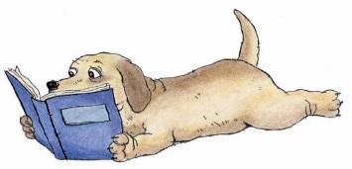
DUE DATE: FRIDAY, DEC. 15th

REMINDERS:
- If a book is too difficult/easy, or you cannot find interest in it, you may exchange the book and choose a different one within the first week of the project. Books can be chosen from our classroom library, a library book, and/or a book from home.
- If you have any questions on how to complete the projects, please let me know and ask me so I can explain the details and expectations.
- Be DETAILED & CREATIVE with your project! You can use crafts, markers, paints, construction paper, poster board, clipart, internet pictures, real pictures, or hand-drawn/colored pictures.
- You can type information for any project, but remember…all the information should be written and presented in your own words. No Plagiarism is permitted!

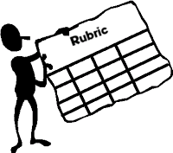
You will be graded on the following:
- Content, Accuracy, and Relevance
- Graphics (photos, pictures, etc.)
- Attractiveness/Creativity/Neatness
- Spelling/Grammar/Mechanics
- Presentation and Preparation…on time!

